**ParrelSync Setup Instructions and Usage**

1. Be in a branch that has ParrelSync installed. (Branches with ParrelSync has it as an option in the Menu Bar). Make sure that you have enough space in storage (You are doubling the space required for the current project).

1. Open the ParrelSync tab and click on the Clone Manager option. This will open a Clone Manager Tab.

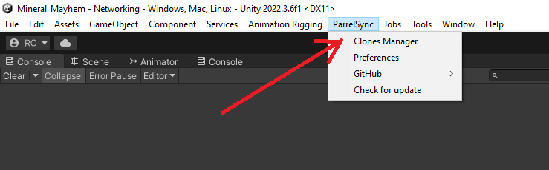

1. Create a new clone using the ‘Create new clone’ function.

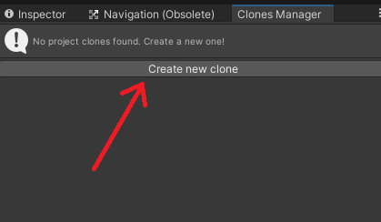

1. Have some coffee (It takes some time to clone the project).



1. Open a clone in a new editor. (This opens a new editor that will need to compile when you make changes to the original project. Do not make changes to the project in the clone because the original does not compile the changes made in the clone.)

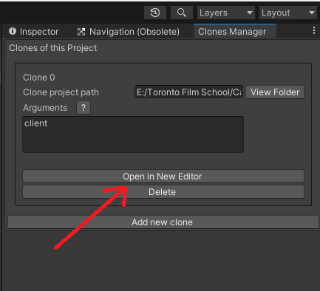

1. Set up the windows so you can view both editors at the same time. You can now play the scene in either editor to test network features.

1. Flex! Congrats. You have ParrelSync up and running.



**Extra Notes:**

Deleting the project does not delete the clone. You will need to go through file explorer to delete the clone if you want to make space in your storage.